¬ ∧ ∨ →

1. 1. A→¬(B∧(A∨C)), A, ¬(B∧(A∨C)), B∧(A∨C), B, A∨C, C
   2. (I∧J)→(¬D∨(A∧C)), I∧J, ¬D∨(A∧C), I, J,¬D, A∧C, D, A, C
2. 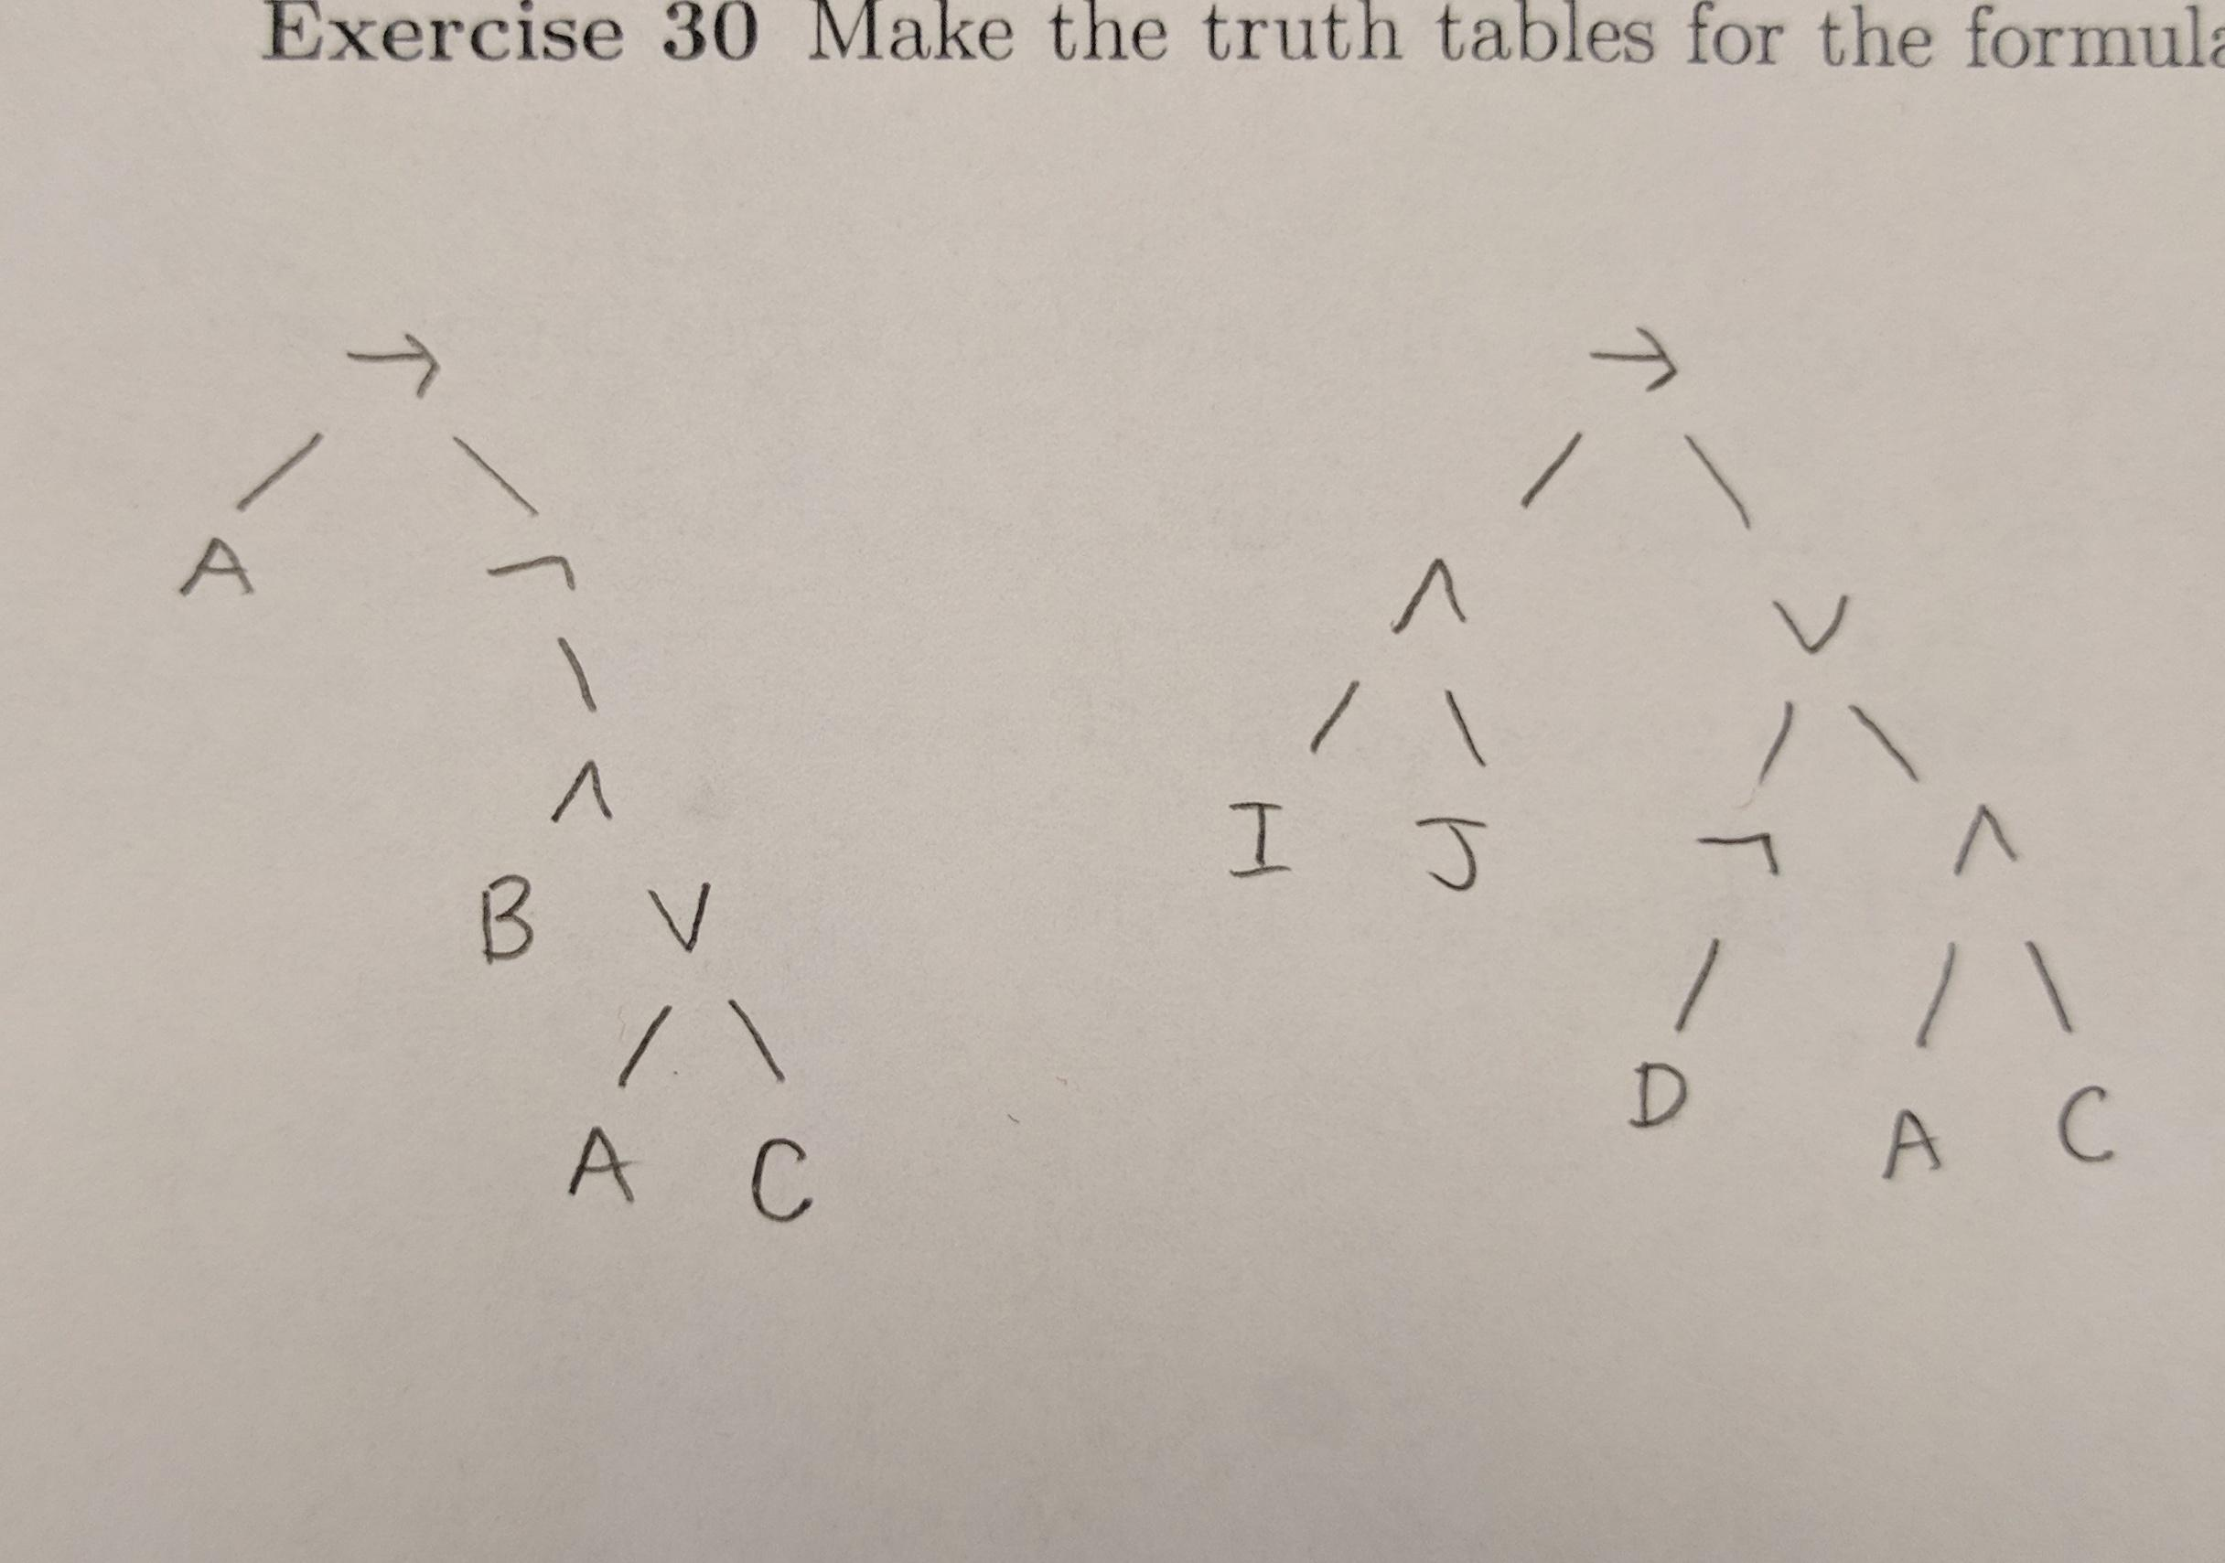
3. 1. Let A(A) = A(B) = 0 and A(C) = 1

*A*(¬((A ∧ B) ∨ C)) = { 1 if *A*((A ∧ B) ∨ C) = 0 }

{ 0 otherwise }

= { 1 if *A*(A ∧ B) = 0 and *A*(C) = 0 }

{ 0 otherwise }

= { 1 if [*A*(A) = 0 or *A*(B) = 0] and *A*(C) = 0 }

{ 0 otherwise }

= 0

1. Let *A*(J) = *A*(P) = *A*(G) = 1  
   *A*(¬J∨(P→G)) = { 1 if *A*(J) = 0 or *A*(¬P∨G) = 1 }  
    { 0 otherwise }  
    = { 1 if *A*(J) = 0 or *A*(¬P) = 1 or *A*(G) = 1 }  
    { 0 otherwise }  
    = { 1 if *A*(J) = 0 or *A*(P) = 0 or *A*(G) = 1 }  
    { 0 otherwise }  
    = 1

30. A.

|  |  |  |  |  |  |
| --- | --- | --- | --- | --- | --- |
| ***A*(A)** | ***A*(B)** | ***A*(C)** | ***A*(A∧B)** | ***A*((A∧B)∨C)** | ***A*(¬((A∧B)∨ C))** |
| 0 | 0 | 0 | 0 | 0 | 1 |
| 0 | 0 | 1 | 0 | 1 | 0 |
| 0 | 1 | 0 | 0 | 0 | 1 |
| 0 | 1 | 1 | 0 | 1 | 0 |
| 1 | 0 | 0 | 0 | 0 | 1 |
| 1 | 0 | 1 | 0 | 1 | 0 |
| 1 | 1 | 0 | 1 | 1 | 0 |
| 1 | 1 | 1 | 1 | 1 | 0 |

30. B.

|  |  |  |  |  |  |
| --- | --- | --- | --- | --- | --- |
| **A(J)** | **A(P)** | **A(G)** | **A(¬J)** | **A(P→G)** | **A(¬J∨(P→G))** |
| 0 | 0 | 0 | 1 | 1 | 1 |
| 0 | 0 | 1 | 1 | 1 | 1 |
| 0 | 1 | 0 | 1 | 0 | 1 |
| 0 | 1 | 1 | 1 | 1 | 1 |
| 1 | 0 | 0 | 0 | 1 | 1 |
| 1 | 0 | 1 | 0 | 1 | 1 |
| 1 | 1 | 0 | 0 | 0 | 0 |
| 1 | 1 | 1 | 0 | 1 | 1 |